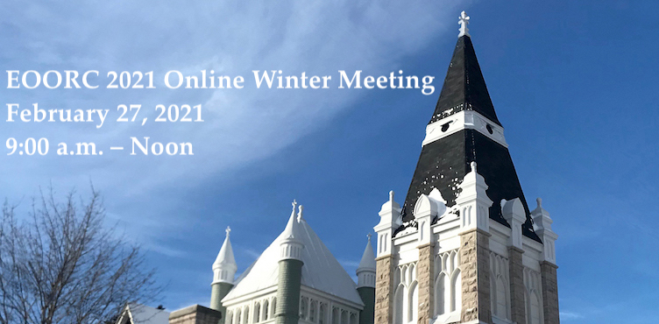
Draft Agenda

9:00 – 9:15 Gathering time
9:15 – 9:55 Worship
9:55- 10:00 Break and transition to workshops
10:00 - 10:55 Workshops (meeting attendees will choose one)
Workshop 1 Cultivating Calm: When you can’t normalize the situation, can you normalize yourself? – Diane Strickland
Workshop 2 Bypassing the pandemic: Community Connection During These Times – Rev. Eric Lukacs and David Patterson
Workshop 3 Steps to Regional Councils Becoming an Affirming Ministry – Linda Hutchinson
10:55 – 11:00 Re-grouping time
11:00– 11:30 Annual Meetings and Annual Reports – Rev. Rosemary Lambie
11:30 – 12:00 Closing Remarks and Blessing

