Eastern Ontario Outaouais Region UCW
Annual General Meeting - Mon., May 9, 2022
Hopeful Revival
Theme Hymn: It only takes a spark VU 289
Isaiah: 40: 31
“ ...those who look to the Lord will win new strength,
They will grow wings like eagles;
They will run and not be weary
They will march on and never grow faint.”

Guest speaker: Trish Elliot
Stewardship & Gifts Officer, Philanthropy Unit
Our annual meeting this year will be live and in person.

Where Trinity United Church, 41 Market St., Smiths Falls, K7A 3N2

When →Registration, meet & greet 9 – 9:45 am, with tea/coffee/muffins provided.
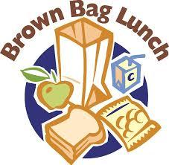
→Gathering Music begins at 9:45 until meeting begins at 10 am.
→Fond farewells will be by 3 PM
Lunch Bring your own bag lunch. Drinks will be provided.

Cost Instead of a set registration fee, a donation bowl will be set out for your contribution. Suggested donation is $10

REGISTRATION: Area presidents of Seaway Valley, Ottawa, Four Rivers and Upper Valley, please send registrations from your areas to Ellen. Please register with Ellen Muise at eemuise@gmail.com by April 25.

Name: ___________________________ Email: ____________________________________________________

Phone: _________________ Home Church (Name & Town) _________________________________

Presbyterial/area (Please check √) Seaway Valley____, Ottawa____, Four Rivers____, Upper Valley____

