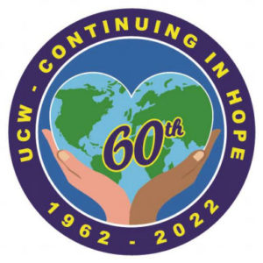
Eastern Ontario Outaouais Region UCW Event
80TH SUMMER EVENT 2022
Celebrating 60 Years of UCW
AUGUST 13-14, 2022

NAME__________________________________________

ADDRESS_______________________________________
________________________________________________

PROV/POSTAL CODE___________________________

TELEPHONE ___________________________________

E-MAIL ________________________________________

AREA/REGION _______________________________

SPECIAL NEEDS (i.e. mobility issues, food allergies) ________________________________________________

IN CASE OF EMERGENCY NOTIFY
_____________________________________________

Early Bird Payment by June 30th
$120 for Saturday/Sunday - $110 Saturday Only
Payment After June 30th
$140 for Saturday/Sunday - $130 Saturday Only

REGISTRATION DEADLINE – JULY 29, 2022

Mail registration form and cheque payable to:
EOOR UCW
Carolle Dallas-Arbuckle
7645 Lawrence St., Vernon, ON K0A 3J0

613-821-2828 cdallas@ripnet.com

Please mark on cheque memo line: Summer Event
Eastern Ontario Outaouais Region UCW Event
80TH SUMMER EVENT 2022
Celebrating 60 Years of UCW
AUGUST 13-14, 2022
Cornwall, Ontario

- Saturday Session will be held at the Ramada Hotel, 805 Brookdale Ave., Adirondack Room
- Hospitality Suite will be open Friday evening for those who are arriving Friday night. BYOB & Snacks
- Registration starting Saturday at 9:00am
- Welcome & Worship starting at 9:30am
- Saturday Session will end at 4:30pm
- Dinner at 5:00pm; Fellowship Time after dinner
- Sunday Worship at Knox-St. Paul’s U.C., 800 Twelfth St. E.
at 10:00am, 613-938-3704; Lunch served following worship
- Accommodations at Ramada Hotel
- You are responsible to book your own room
- $135.99 plus tax (2 – 4 people/room), room rate good for Thursday through to Monday
- Block of rooms will be on hold until June 30th
- 1-613-933-8000 or 1-888-900-5762
- Bookings under “Summer Event”

- DISPLAY TABLES
  - Grand River Books
  - Fair Trade
  - Mission & Service / Stewardship Resources
  - UCC’s Then Let Us Sing! Project

- Please bring with you
  - Bible - Voices United & More Voices
  - A Photo from your UCW Journey

INFORMATION – Contact Kim Baird
613-362-0640 or bairdjk4@gmail.com

