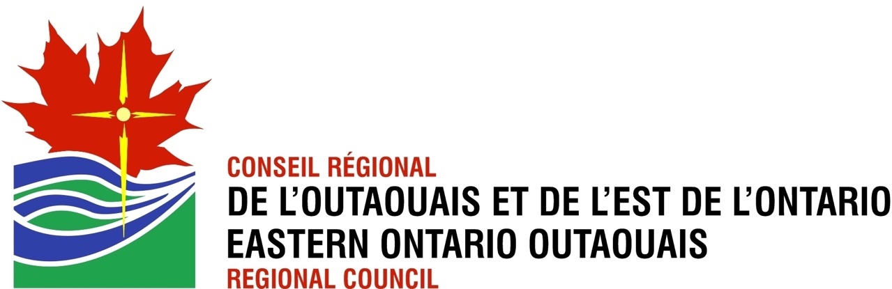

Nominations for EOORC 2022
We are preparing for the Annual Meeting May 27 – 28, 2022. We know it is perhaps difficult to feel enthusiastic about being on a team, however, without team members, the work of Eastern Ontario Outaouais Regional Council will not be done. As the Hymn we sing so caringly says, “Your Work O God Needs Many Hands.” That is what we need so that we can accomplish more and fulfill our Mission.

In particular, we are missing the votes and voices from the Ottawa Area. Please consider even one year.

EOORC Current Needs

The Nominations Committee needs two more Lay People to be voting Commissioners for our Region on General Council 44 “Who do you say I am”
~ It is not too late; all meeting have been online and are recorded
~ Right now, we are in the learning phase about the Petitions, you can follow along in the recordings
~ In June we will be in the discussion phase when you can make your opinion known
~ During the last 2 weeks in July we will be voting and having further discussion
~ over the next three years After the close of GC 44 you will attend three meetings as a commissioner

We are also looking for President-Elect for the Region please fill in Expression of Interest form. If you are not sure and want to try out the Executive for onne year, let us know, we can accommodate.

As well we have the following leadership team positions
Executive Team: 1 Lay
1 Ordered Minister
Communications: 1 Member
Nominations: 3 Members ( we would really appreciate at least one person from Ottawa)
Vision and Transformation: 3 Members
Ottawa School of Theology and Spirituality: 1 Representative (There are currently no United Church members)

