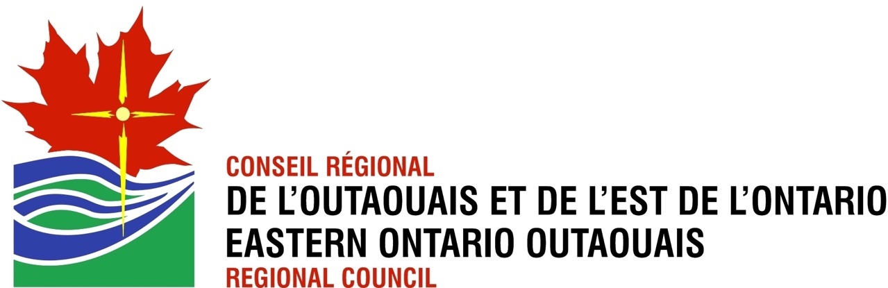

OTTAWA

November 13, 2023

RE: Designated Lay Ministers (DLMs) in EOORC

Siblings in Christ,

Greetings in the name of our Great Redeemer, Model and Head of the Church.

Over the last few years, there have been discussions about the different streams of ministry in the United Church of Canada. With the changes in the processes for those seeking to be ordained or commissioned, the Office of Vocation has a more wholistic approach to candidacy that means that the openness and availability for those who wish to pursue ministry is not as rigid as it once was.

During the General Council meeting in the summer of 2022, a proposal was approved that would begin the process of wrapping up the Designated Lay Ministry program in the United Church. The General Council was asked to prepare the process for ending this program.

At the General Council meeting in October 2023, a detailed proposal to navigate this change was adopted. It included pathways to allow existing DLMs to be moved into the traditional ordination stream, allowed existing DLMs and those in training to continue serving the church in this way if that is what they were called to do, and had highlighted some recommendations for how Regional Councils might adopt rules within their own jurisdictions to handle this change.

As a result, a proposal was presented to the Executive of the Eastern Ontario Outaouais Regional Council on Thursday, November 9th that would respond to these recommendations.

* It gives Regional Council corresponding membership to retired DLMs, which means they do not lose their status when they are retired.
* It will allow retired DLMs to become Voluntary Associate Ministers, which allows them to maintain an accountable relationship with a congregation, including a marriage license, even though they are retired.
* It will give retired and active DLMs sacramental privileges when requested.
* It will allow more flexibility for DLMs to move from one congregation to another without complexity.

This proposal was adopted and responds fully to the recommendations of the General Council proposal.

If you know of a retired DLM in your community, please encourage them to reach out the President of the Regional Council and myself so that we can take the appropriate steps with them to confirm their status and path forward. Because DLMs have historically lost their status upon retirement, we do not have contact with all the DLMs that may be in our region. This is why your help in identifying them will enable us to have more complete lists. President: Sue Hutton, [suehuttoneoorc@gmail.com](mailto:suehuttoneoorc@gmail.com), Regional Executive Minister, Éric Hébert-Daly [ehebertdaly@united-church.ca](mailto:ehebertdaly@united-church.ca).

If you are an active DLM or know of one who may be interested in pursuing the ordination path, please have them reach out to Caroline Penhale, the Office of Vocation Minister for this region. [cpenhale@united-church.ca](mailto:cpenhale@united-church.ca). If they wish to obtain sacramental privileges, they should contact the Pastoral Relations Minister, Whit Strong at [wstrong@united-church.ca](mailto:wstrong@united-church.ca).

If a retired DLM is seeking Voluntary Associate Minister status (particularly if they wish to obtain a marriage license), they should reach out to Joel Miller ([jmiller@united-church.ca](mailto:jmiller@united-church.ca)) to obtain the form that needs to be filled out by the DLM and their community of faith.

Some members have asked why the General Council made this decision after the “one order of ministry” remit was defeated in 2018. The DLM program is only one stream of ministry. Diaconal ministry, candidate supply, licensed lay worship leaders, etc. are seeing no change in their status as a result of this decision. It relates only to DLMs.

If you have any other questions about this, please don’t hesitate to reach out to us.

Yours in Christ,



Rev. Éric Hébert-Daly

Regional Executive Minister