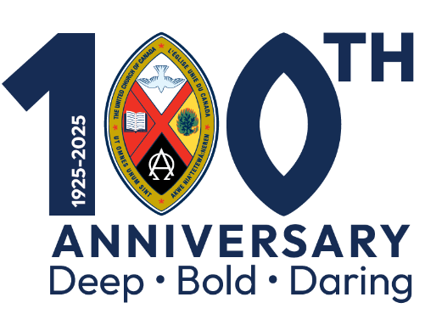

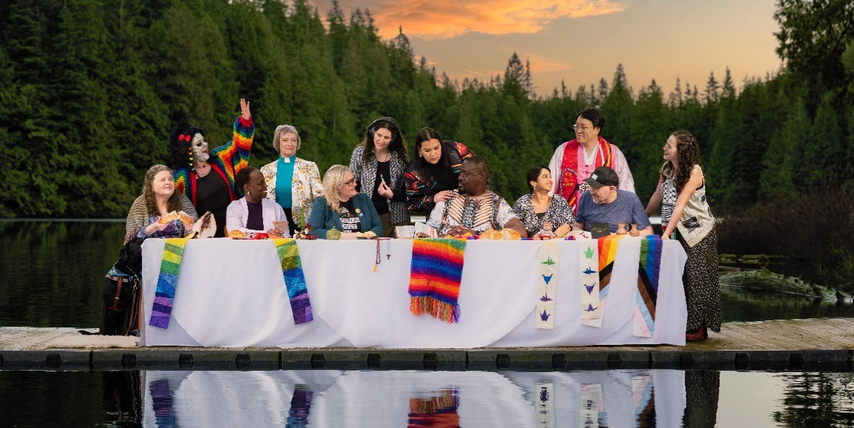

***The Journey Continues…***

***Eastern Ontario Outaouais***

***Regional Gathering***

*Sunday, June 15, 2025*

**Gathering**

**Hymn:** Draw the Circle Wide **MV** # 145

**Welcome** *Reverend Cindy Casey*

**Indigenous Welcome**  *Grandmother Irene Compton*

**Lighting of the Christ Candle** *Reverend Susan DeHaan*

**Acknowledgement of the Land** *Reverend Nancy Best*

**Introit:** Love Each Other *100th Anniversary Choir*

**Children’s Time** *Standing Side by Side* *Reverend Alwin Maben*

**Engaging in Prayer**

**Celebration & Lament** *Reverend Cindy Casey*

**Both Sides Now** *Leah Cogan & Field Notes*

**The Word Read and Proclaimed**

**Prayer for Illumination** *Rousseau Whiteley*

**Scripture Reading**

Epistle Lesson: Revelations 21:1–6 *Rousseau Whiteley*

Gospel Lesson: John 15:9–17  *Oakley Hart*

**Song:** Love Each Other Reprise

**Sermon: “**Proud Past – Hopeful Future”

*The Hon. Rev. Dr. Robert Oliphant, P.C., M.P.*

**Music: Blessed Assurance *Emmanuel Simon & Field Notes***

**Response to The Word**

**Invitation to The Offering** *Reverend Cindy Casey*

**Musical Offering**

**\*Offertory:** What Can I Do? **MV** # 191

*What can I do? What can I bring? What can I say?*

*What can I sing? I'll sing with joy. I'll say a prayer.*

*I'll bring my love. I'll do my share.*

© by Paul Rumbolt and Michele McCarthy

**Offertory Prayer**  *Reverend Takouhi Demirdjian-Petro*

**Celebration of Holy Communion**

*Reverend Éric Hébert-Daly*

*Reverend Cindy Casey*

**The Lord’s Prayer**

Our Creator, who art in heaven, hallowed be thy name.

Thy kingdom come, thy will be done   
on earth as it is in heaven.

Give us this day our daily bread; and forgive us our trespasses, as we forgive those who trespass against us;

and lead us not into temptation but deliver us from evil.

For thine is the kingdom, the power, and the glory, for ever and ever. Amen.

**Music Interlude**

**Prayers of the People**

*As the Prayers are being offered, the music of “Lord, Listen to Your Children Praying” (VU #400) will accompany, and the congregation is invited to*

*sing during the candle lighting.*

**Closing Hymn:** Love Divine, All Loves Excelling **VU** # 333

**Commissioning and Benediction**

**Choral Amen**

**Closing Music:** I Wish I Knew How It Would Feel to Be Free

*Field Notes*

***Contributing to Today’s Celebration***

***Worship Leadership***

Rev. Cindy Casey, Liturgist

Grandmother Irene Compton, Indigenous Welcome

Rev. Susan DeHaan, Lighting of the Christ Candle

Rev. Nancy Best, Land Acknowledgement

Rev. Alwin Maben, Children’s Time

Rousseau Whiteley, Reader

Oakley Hart, Reader

The Hon. Rev. Dr. Robert Oliphant, P.C., M.P., Speaker

Rev.Takouhi Demirdjian-Petro, Offertory Prayer

Rev. Éric Hébert-Daly, Celebrant, Prayers of the People

Rev. Dr. Kimberley Heath, Prayers of the People

Rev. Whit Strong, Prayers of the People

Rev. Kofi Akoussah, Prayers of the People

Barbra DeJeet, Prayers of the People

Karen Valley, Prayers of the People

***Musicians & Vocalists***

Field Notes

Rev. Peter Woods- Saxophone, Music director

Nick Gummeson- Keyboard, Music Director

Leah Cogan - Voice

Emmanuel Simon- Voice

Betty Ann Bryanton- Voice

Kyle Jordan - Guitar

Chris Pond - Bass

José García – Drums

100th Anniversary Choir

***Production Team***

David Clemis

Gary McKay

Karen McLean

David Patterson, Lead

Glen Patterson

Keith Penny

Kingston Sound, Rob Bailey AV Supplier

***Your 100th Anniversary Worship Leadership Team***

Ruth Bryce, Museum Curator

Rev. Cindy Casey, Chair

Liz Church, Ushers & Greeters Coordinator

Dana Ducette, Youth Coordinator

Nancy Hazen, Team Member

Rev. Susan Hutton, Team Member

Rev. Alwin Maben, Team Member

Rev. Natalie Matkovsky, Communications

David Patterson, Logistics/AV Coordinator

Kathryn Peate, Communion Coordinator

Rev. Michelle Robichaud, Children’s Program Coordinator

Rev. Mary Royal Duczek, Secretary

Cathy Ryan, First Aid Coordinator and Liaison

Paul Whiteley, Team Member

Rev. Peter Woods, Music Coordinator

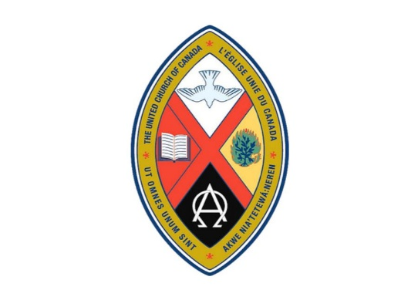

*The Journey Began…*

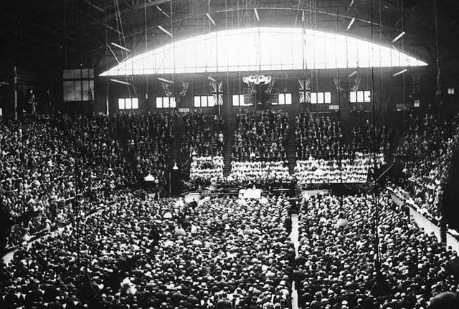

*Mutual Street Arena, Toronto, Ontario – June 10, 1925*