Worship at
X

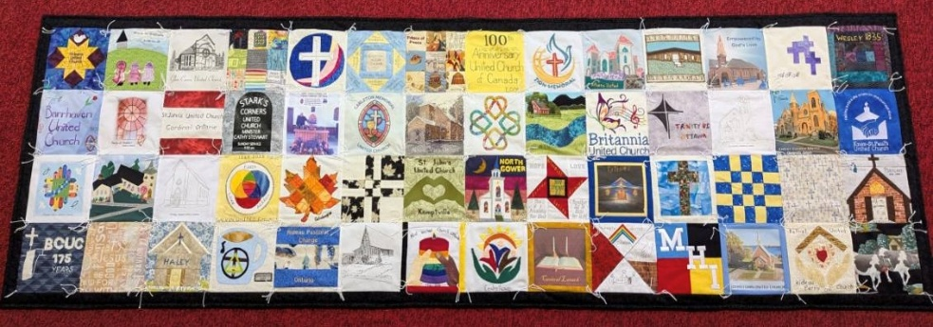

Visit of the
100th Anniversary Quilt

Add Date

Gathered by God

Prelude

Welcome

Call to Worship

Stitch us together, O Holy One.
We have come with our pockets
filled with the fabric of our lives:
memories of our yesteryears, present patches and
fragmentary dreams and visions of our tomorrows.
Stitch us together, tailor us to your truth.
Some of us, lo, are frayed and worn;
some of us are ironed on hastily,
our edges curling prematurely;
some of us are carefully stitched over time;
some are untimely torn…
Stitch us together, O Holy One,
and let your Holy Spirit stitch in us seams of grace
Empower us to be a crazy, beautiful quilt of your love, challenge and story.
We are topstitched, backstitched, and dropstitched,
zig-zag, curved, and straight, full of color and texture,
Stitch us together, O Holy One,
that all might receive what they need for another day,
Patterned by our tailor Jesus
whose seams are wide with mercy and forgiveness,
and whose heart’s quilt enwraps us all.
Stitch us together today, O Holy One,
with your piercing promise,
and raise us and your Church,
a garment of new life,
clothing for a new day.
Lighting of the Christ Candle

Opening Prayer

Hymn It’s A Song of Praise to the Maker MV 30

Sign of Peace

Hymn I Am Walking A Path of Peace MV 221

Listening for the Word

Theme Conversation

Reading Matthew 9:14-17

Anthem

Reflection

Inspired by the Word

Hymn My Love Colours Outside the Lines MV 138

Time of Offering

Prayers of the People

Prayer of Jesus

Sent by the Spirit

Hymn A Song Must Rise VU 142

Sending Forth

Postlude



